**Exercise**

1. Retrieve the product names and their corresponding quantities in stock for products with quantities below 50. Sort the list by quantity in ascending order. (Table: Products)

**Solution:**

use Northwind;

SELECT ProductName,

UnitsInStock FROM Products

WHERE UnitsInStock < 50

ORDER BY UnitsInStock ASC;

**Output:**

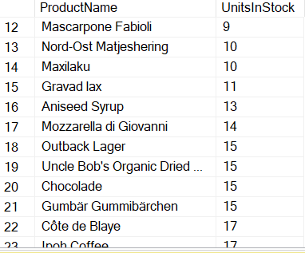

1. List the employee names and their hire dates for employees hired in the year 2023. Order the results by hire date in descending order. (Table: Employees).

**Solution:**

use Northwind;

SELECT FirstName,

HireDate FROM Employees

WHERE YEAR(HireDate) = 2023 ORDER BY HireDate DESC;

**Output:**

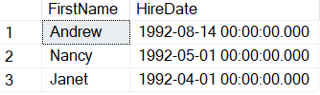

1. Display the highest, lowest, sum and average UnitPrice of each Category, where highest UnitPrice lies in the range of 50$ to 100$. Label column as CategoryId, Maximum, Minimum, Sum and Average, respectively. (Table: Products)

**Solution:**

use Northwind;

SELECT CategoryID,

MIN(UnitPrice) AS [Min Unit Price],

MAX(UnitPrice) AS [Max Unit Price],

AVG(UnitPrice) AS [Average Unit Price],

SUM(UnitPrice) AS [Sum of Unit Price]

FROM Products GROUP BY CategoryID

HAVING MAX(UnitPrice) BETWEEN 50 AND 100;

**Output:**

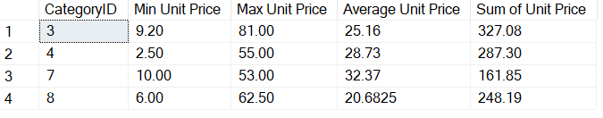

1. From customers table, Count all customers in each region where region is not null. (Table:

Customers).

**Solution:**

SELECT Region,COUNT(*) AS Total_Customer FROM Customers WHERE Region IS NOT NULL GROUP BY Region;

**Output:**

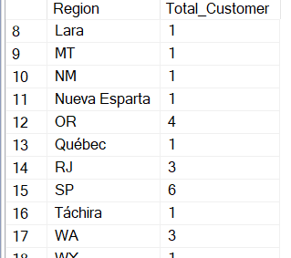

1. Write a query to display the number of ContactName with same ContactTitle. Sort contact title in descending order. (Table: Customers).

**Solution:**

SELECT ContactTitle, COUNT(ContactName) AS NumberOfContacts

FROM Customers

GROUP BY ContactTitle

ORDER BY ContactTitle DESC;

**Output:**

1. Write a query that count all orders against each product id. No of orders should be greater than 50. (Table: [Order Details]).

**Solution:**

use Northwind

SELECT ProductID,count(*)

AS NumberOfOrders

FROM [Order Details]

GROUP BY ProductID HAVING count(*) > 50;

**Output:**

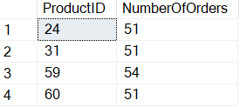

1. How many people are in each unique city in the employee table that have more than one person in the city? Select the city and display the number of how many people are in each if it's greater than 1. (Table: Employees)

**Solution:**

use Northwind;

SELECT City, COUNT(*) AS NumberOfPeople

FROM Employees

GROUP BY City

HAVING COUNT(*) > 1;

**Output:**

1. Find the product name, maximum price and minimum price of each product having maximum price greater than 20.00 $. Order by maximum price.

**Solution:**

SELECT ProductName,MAX(UnitPrice) AS MaxPrice, MIN(UnitPrice)

AS MinPrice FROM Products

WHERE ProductID IN

(SELECT ProductID FROM [Order Details]GROUP BY ProductID HAVING MAX(UnitPrice) > 20.00

)GROUP BY ProductName ORDER BY MaxPrice;

**Output:**

1. Write a query to list no of customers with same ContactTitle if No of customers is greater than 5. However their ContactTitle does not contain Manager. Order by contact title in Descending order(Table: Customers)

**Solution:**

SELECT ContactTitle,

COUNT(*) AS

NumberOfCustomers FROM Customers

WHERE ContactTitle NOT LIKE '%Manager%'

GROUP BY ContactTitle HAVING COUNT(*) > 5 ORDER BY ContactTitle DESC;

**Output:**

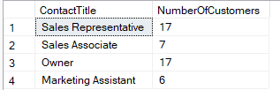

1. Retrieve the count of products in each category where the unit price is less than 30 dollars. Label the columns as CategoryID and ProductCount. (Tables: Products)

**Solution:**

SELECT CategoryID,COUNT(*)

AS ProductCount FROM Products

WHERE UnitPrice < 30.00 GROUP BY CategoryID;

**Output:**

